Homework: SQL is easy

Example:

1. Select all articles from the **article** table.

Command:

SELECT * FROM article;

 Screenshot of the result:

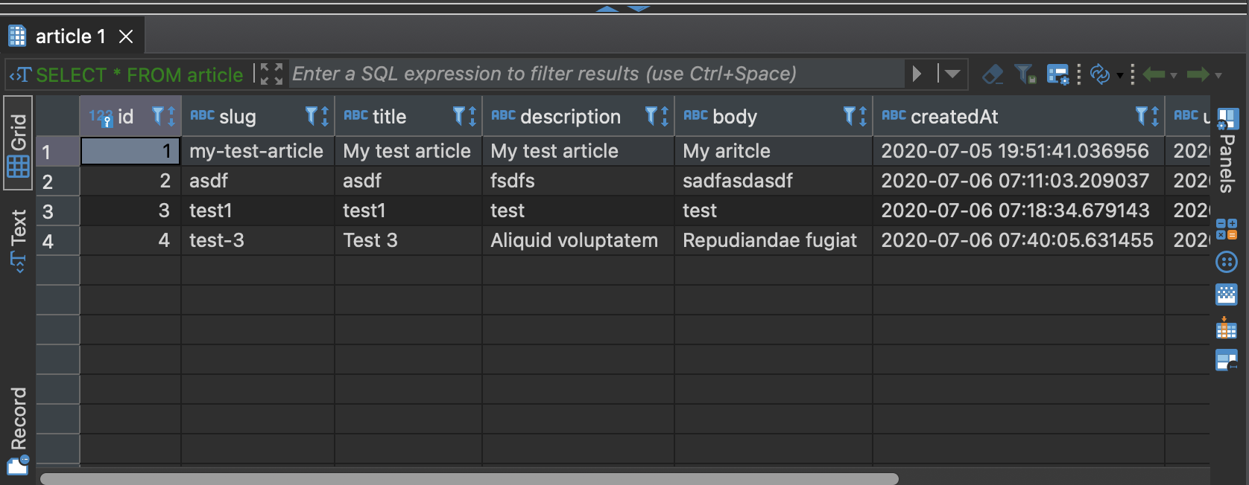

1. Create a new table **reviews_test**.

Command:

CREATE TABLE reviews_test(

id INTEGER PRIMARY KEY,

review_name TEXT UNIQUE,

review_text TEXT NOT NULL,

review_author_id INTEGER UNIQUE,

article_id INTEGER UNIQUE);

 Screenshot of the result: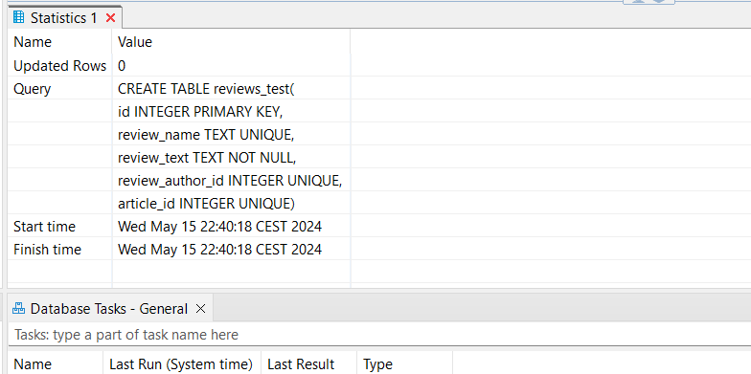

1. Insert 5 new records to the **reviews_test** table.

Command:

INSERT INTO reviews_test (

id,

review_name,

review_text,

review_author_id,

article_id,

) VALUES (

1,

'Pola',

'Description for my test',

'24563',

'1-1'),(

2,

'Kevin',

'My hobby is a football',

'123',

'2-2'),(

3,

'Laura',

'Slim body is beautiful',

'356',

'3-1'),(

4,

'Nikita',

'Sport is my life',

'754',

'4-1'),(

5,

'Andrew',

'I do not like spiders',

'189',

'5-1');



Screenshot of the result:

I forgot to make a screen for this task.

1. Select all records from the **reviews_test** table.

Command:

SELECT * FROM reviews_test;

 Screenshot of the result:

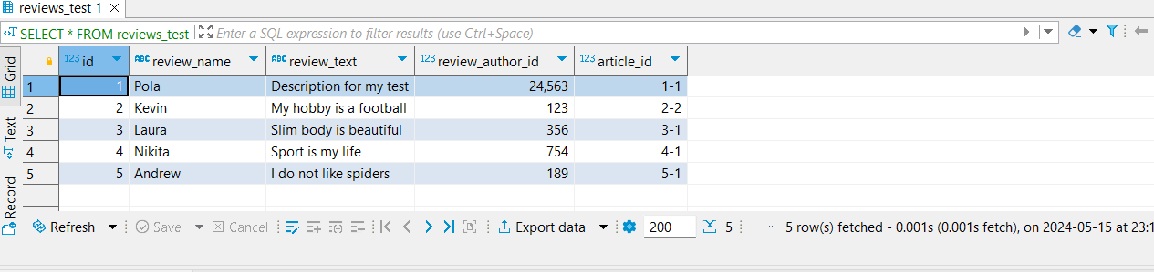

1. Select all records from the **article** table.

Command:

SELECT * FROM article;

 Screenshot of the result:



1. Alter the **reviews_test** table: add a new column *created_at*.

Command:

ALTER TABLE reviews_test

ADD COLUMN created_at;

 Screenshot of the result:

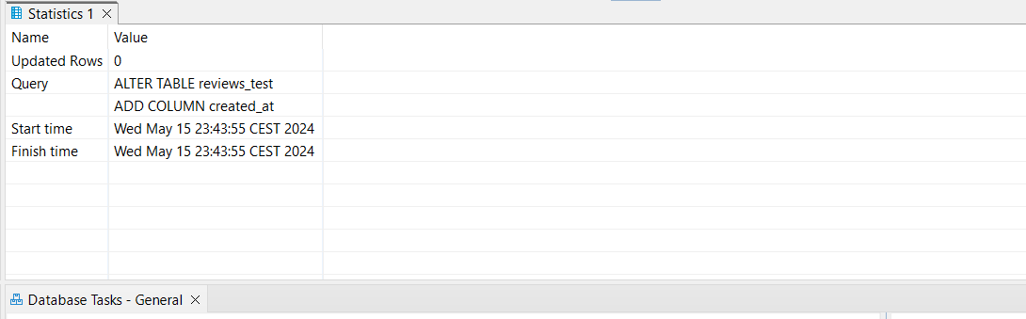

1. Update all other records in the **reviews_test** table

Command:

 UPDATE reviews_test

SET created_at = '01-01-2222';

 Screenshot of the result:

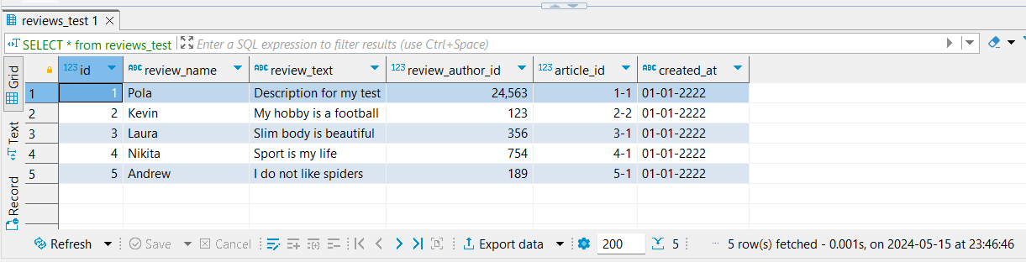

1. Delete the last 2 records in the **reviews_test** table.

Command:

DELETE FROM reviews_test

WHERE id = 4;

DELETE FROM reviews_test

WHERE id = 5;

 Screenshot of the result:

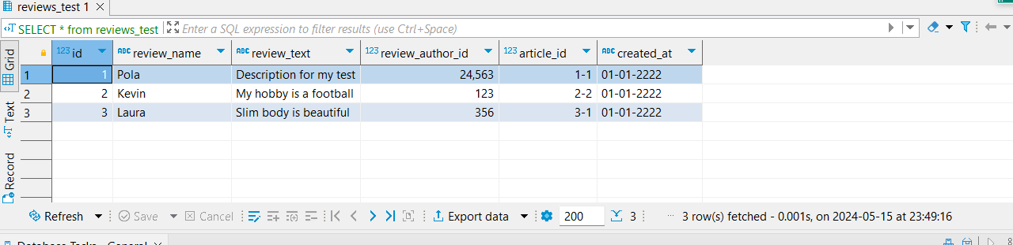

1. Create a new table **reviews**.

Command:

CREATE TABLE reviews (

id INTEGER PRIMARY KEY,

review_name TEXT UNIQUE,

review_text TEXT DEFAULT 'Default description',

review_author_id INTEGER NOT NULL,

article_id INTEGER UNIQUE);

 Screenshot of the result:

